## CHANDIGARH UNIVERSITY

## UNIVERSITY INSTITUTE OF NGINEERING

**DEPARTMENT OF COMPUTER SCIENCE & ENGINEERING**



|  |  |
| --- | --- |
| **Submitted By: Submitted To:**  Vivek Kumar(21BCS8129) Neha Dutta(E12830) | |
| **Subject Name** | Design and Analysis of Algorithm Lab |
| **Subject Code** | 20CSP-312 |
| **Branch** | Computer Science and Engineering |
| **Semester** | 5th |

**Experiment - 10**

**Student Name: Vivek Kumar UID: 21BCS8129**

**Branch: BE-CSE(LEET) Section/Group: 20BCS-WM-616/A**

**Semester: 5th Date of Performance: 07/11/2022**

**Subject Name: DAA Lab Subject Code: 20CSP-312**

1. **Aim/Overview of the practical:**

Code and Analyze to find all occurrences of a pattern P in a given string S.

**2. Task to be done/ Which logistics used:**

Code and Analyze to find all occurrences of a pattern P in a given string S.

**3. Requirements (For programming-based labs):**

* Laptop or PC.
* Operation system (Mac, Windows, Linux, or any)
* Vs-Code with MinGw or any C++ Compiler

**4. Steps for experiment/practical/Code:**

#include <bits/stdc++.h>

using namespace std;

/*

Function to find

All occurrences of the pattern in the string

*/

void solve(string str, string pat)

{

    // Initialising N and M

    int n = str.size();

    int m = pat.size();

    // Iterating over the string

    for (int i = 0; i < n; i++)

    {

        // Iterating over the pattern

        for (int j = 0; j < m; j++)

        {

            // If any character mismatches, break

            if (i + j >= n || pat[j] != str[i + j])

                break;

            /*

            If we are at the last index,

            Print the occurrences of the pattern in the string

            */

            if (j == m - 1)

                cout << i << ' ';

        }

    }

    cout << endl;

}

// Driver Code

int main()

{

    string str, pat;

    cout << "Enter your String and pattern respectively" << endl;

    cin >> str >> pat;

    solve(str, pat);

}

**5. Output:**

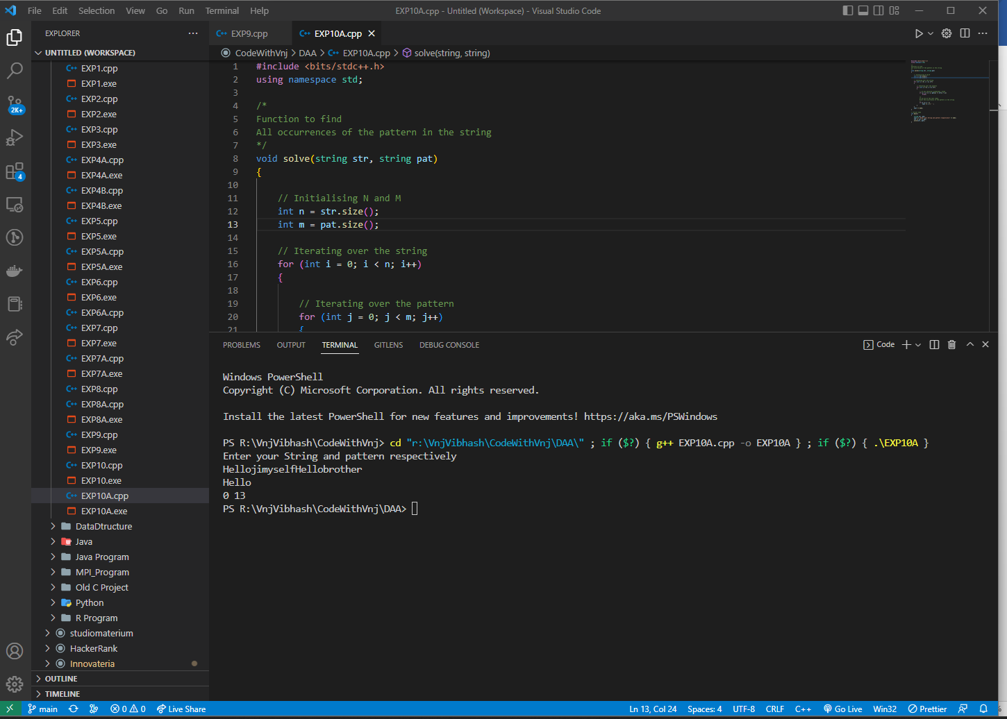

**Learning outcomes (What I have learnt):**

1. How to solve the Pattern Matching Algorithm using dynamic programming.

**Evaluation Grid (To be created per the faculty's SOP and Assessment guidelines):**

|  |  |  |  |
| --- | --- | --- | --- |
| Sr. No. | Parameters | Marks Obtained | Maximum Marks |
| 1. | Worksheet completion including writing learning objectives/Outcomes.  (To be submitted at the end of the day). |  |  |
| 2. | Post-Lab Quiz Result. |  |  |
| 3. | Student Engagement in  Simulation/Demonstration/Performance and Controls/Pre-Lab Questions. |  |  |
|  | Signature of Faculty (with Date): | Total Marks Obtained: |  |